1. Employee Portal will use Employee Microservice. For this we have registed the services in Eureka. And for consuming service we have used openfeign spring cloud configuration.
2. Also we have Implemented hysterix-circuit breaker as if the main employee-microservice is down, employee-portal service should not be down and it is handling the process And show the message that the employee micro service is down and try later.

It has also 4 end points.

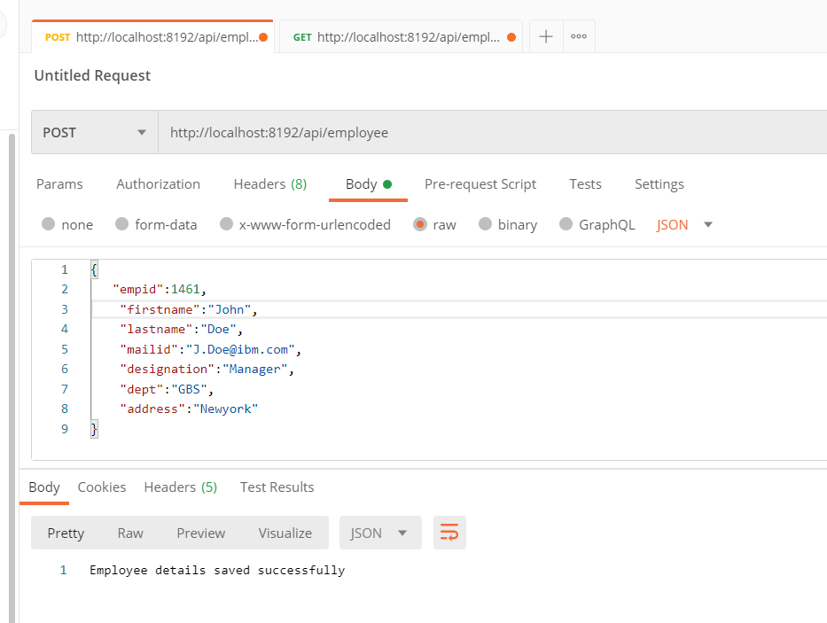

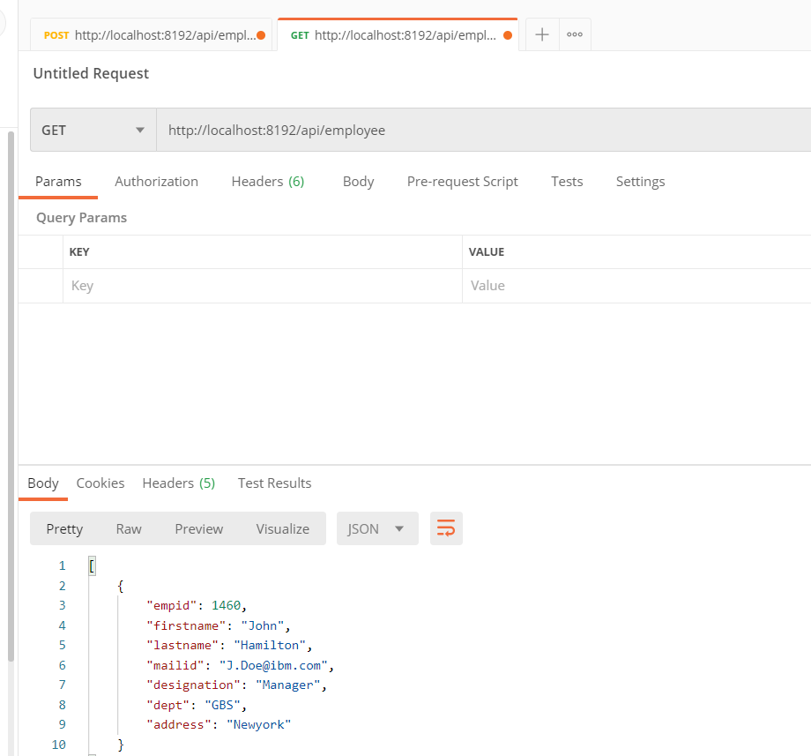

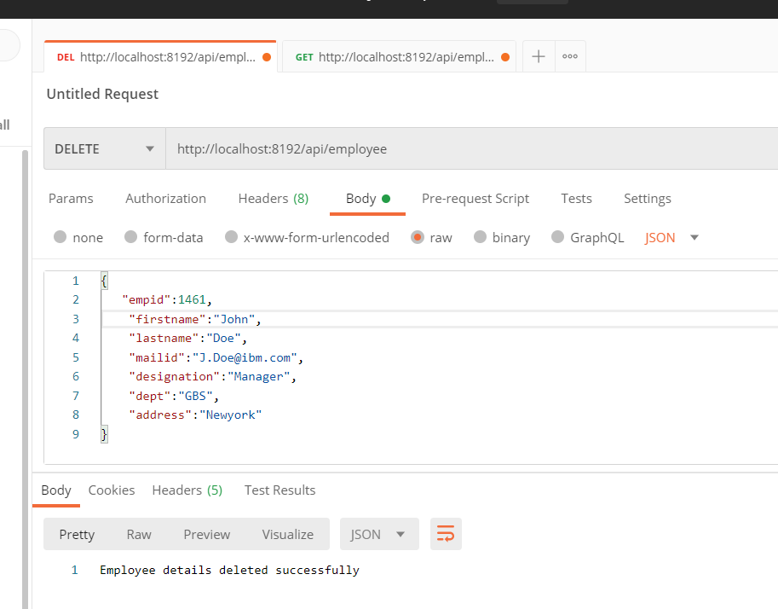

Also for UI of services : We have provided the swagger Information as well :

<http://localhost:8192/swagger-ui.html>